

**AUTONOMOUS ROBOT**

**CHALLENGE**

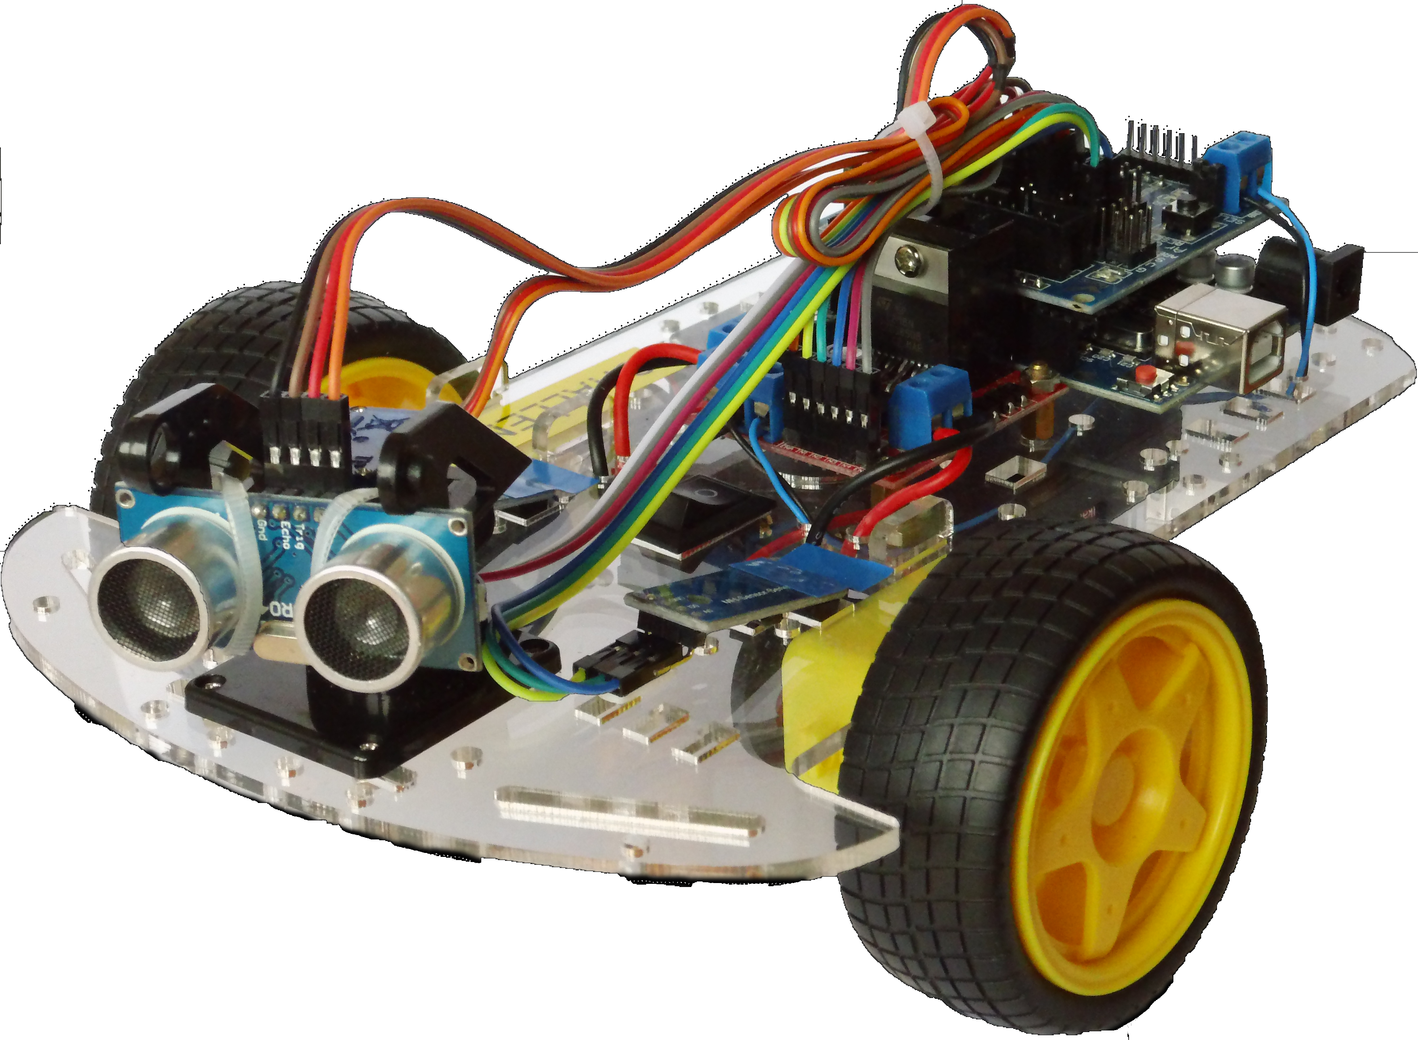

Some place - January 26

**We have a challenge for you! Build and**

**program your own autonomous robot and compete with your strategy against your colleagues.**

The general idea is to spend an evening with

developers exploring an interesting subject in a

creative format.

For the first event, we will spend two evenings

(about one month apart) working on one subject:

building and programming a small autonomous

robot.

On the first evening the participants will use their

ingenuity to build an autonomous robot by

expanding on robot “hello world”

software.

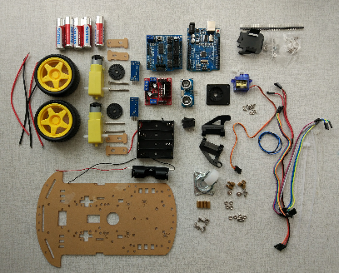

On the second evening a robot

assignment will be issued that must be put in to

code. The robot that completes the given task

wins a prize (and eternal fame, of course). You

may work alone or as a team. In this assignment

we will be competing amongst ourselves.

**Own contribution**

The robot kits will require a financial contribution

of the participants. This is €15,- per participant /

robot. Of course the robot will be your property

afterwards.

For people who cannot attend one of the

evenings it's not a problem. Instructions and

software will be provided for home participation if desired.

**Program**

|  |
| --- |
| 16:30 Welcome, explanation |
| 17:00 Building your robot |
| 18:30 Dinner (Pizza) |
| 20:30 Back to work |
| 21:00 Wrap-Up |

**Date**

We will be setting the date using “date chooser”.

See instructions in the email.

**Robot**

The robots will run on an Arduino Uno

microprocessor board, have two independently

controllable motors with wheels, two

speed/rotation sensors and an ultrasonic

distance sensor.

**Registration**

The robot kits need to be ordered well

beforehand so we need to know fairly soon who

will be participating. See email.

Organizer One

Organizer Two

We are looking forward to your participation and

regret in advance how well our robot will do

compared to yours.